WEEK 3
STATISTICAL ANALYSIS AND HYPOTHESIS TESTING
Titanic Passenger Dataset

Virtual Data Science with Python Apprentice Intern
Student Name: Sharanya A

1. Introduction
Week 3 focuses on statistical analysis and hypothesis testing using Python. The Titanic passenger dataset was selected because it contains categorical and numerical variables suitable for statistical investigation. Building on the exploratory analysis performed in Week 1 and the visualization work completed in Week 2, this task investigates whether passenger gender was statistically associated with survival.
A Chi-Square Test of Independence was selected because both variables in the research question are categorical: gender (male/female) and survival status (0/1). Cramér's V was also calculated to describe the strength of the association.

2. Objective
To determine whether there is a statistically significant association between passenger gender and survival status in the cleaned Titanic dataset.

3. Hypothesis Formulation
Null Hypothesis (H₀): There is no significant association between passenger gender and survival.
Alternative Hypothesis (H₁): There is a significant association between passenger gender and survival.
Significance level (α): 0.05

4. Dataset and Preparation
The analysis used the cleaned Titanic dataset prepared during Week 1. The dataset contained 784 records and 14 variables after the earlier cleaning process. The relevant variables for this analysis were sex and survived.
The survival-rate results used in this statistical analysis were approximately 21.59% for male passengers and 74.06% for female passengers.

5. Statistical Methodology
The Chi-Square Test of Independence evaluates whether two categorical variables are independent. A contingency table was first created for gender and survival status. The Chi-Square test was then applied using SciPy. The p-value was compared with α = 0.05.
In addition, Cramér's V was calculated. Unlike the p-value, which addresses statistical significance, Cramér's V provides an indication of the strength of association.

6. Python Implementation
import pandas as pd
import numpy as np
from scipy.stats import chi2_contingency
df = pd.read_csv("titanic_cleaned.csv")
contingency_table = pd.crosstab(df["sex"], df["survived"])
chi2, p_value, degrees_of_freedom, expected = chi2_contingency(
contingency_table
)
alpha = 0.05
n = contingency_table.sum().sum()
cramers_v = np.sqrt(
chi2 / (n * min(
contingency_table.shape[0] - 1,
contingency_table.shape[1] - 1
))
)
print("Chi-Square Statistic:", round(chi2, 4))
print("P-value:", p_value)
print("Degrees of Freedom:", degrees_of_freedom)
print("Cramer's V:", round(cramers_v, 4))

7. Statistical Test Results
Measure | Result
Chi-Square Statistic | 203.6143
P-value | 3.3973191841101995 × 10⁻⁴⁶
Degrees of Freedom | 1
Cramér's V | 0.5109
Significance Level (α) | 0.05
The p-value is substantially smaller than 0.05. Therefore, the null hypothesis is rejected. There is strong statistical evidence of an association between passenger gender and survival.

8. Chi-Square Assumption Check
For the Chi-Square Test of Independence, expected frequencies should be sufficiently large. The expected frequencies obtained from the analysis were:
Gender | Survived = 0 | Survived = 1
female | 171.46 | 120.54
male | 286.54 | 201.46
The minimum expected frequency was 120.54, which is well above 5. Therefore, the expected-frequency condition is satisfied and the Chi-Square test is appropriate for this analysis.

9. Visualization Supporting the Test
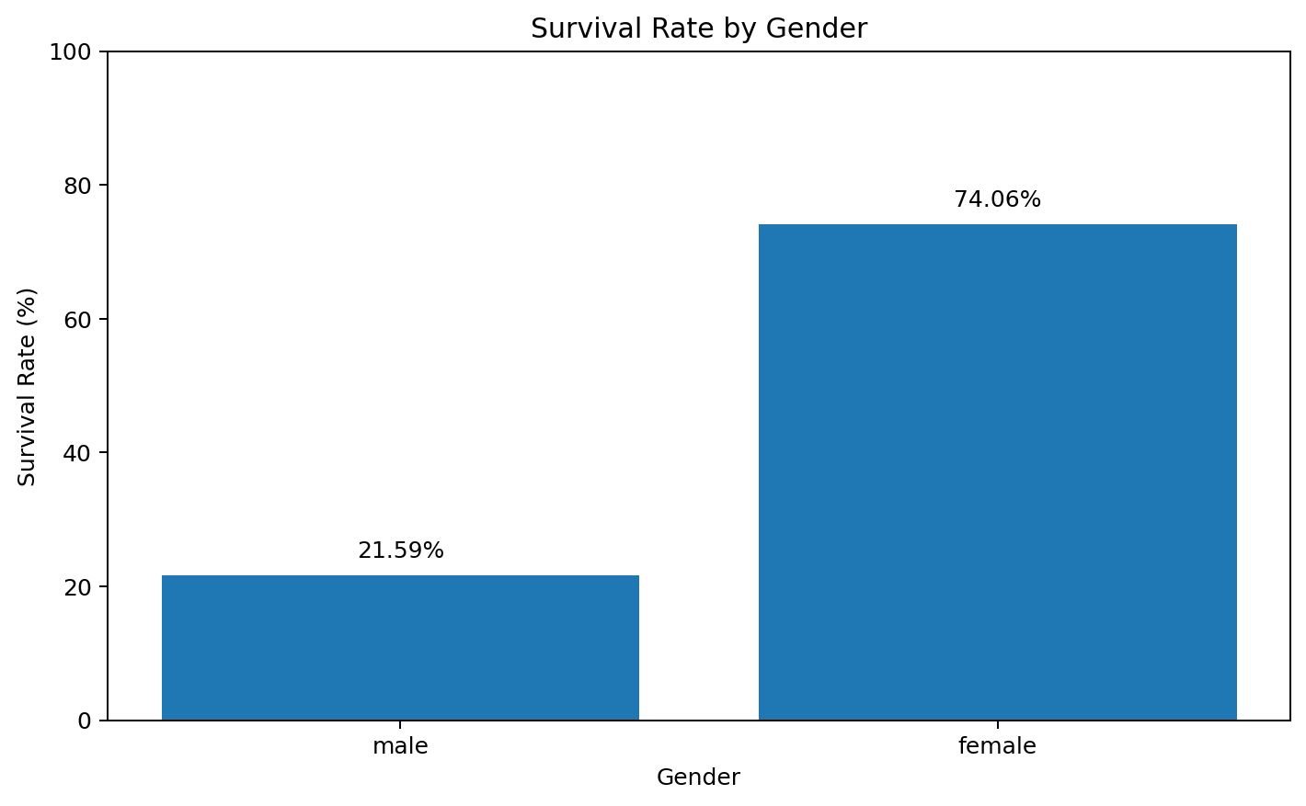
Figure 1. Survival rate by passenger gender.
The visualization shows a large difference in survival rates between the two gender groups. Female passengers had a survival rate of 74.06%, whereas male passengers had a survival rate of 21.59%. This visual pattern is consistent with the statistically significant Chi-Square result.

10. Interpretation
The statistical test provides strong evidence that gender and survival were not independent in the analyzed Titanic data. The very small p-value means that observing a difference of this magnitude would be extremely unlikely if gender and survival were actually independent.
Cramér's V was 0.5109, indicating a substantial association between gender and survival. However, statistical association should not automatically be interpreted as proof that gender alone caused the difference. Other variables, including passenger class, age, family structure, and fare, may also have contributed to survival outcomes.

11. Key Findings
- The Chi-Square statistic was 203.6143.
- The p-value was 3.3973 × 10⁻⁴⁶, far below the 0.05 significance level.
- The null hypothesis was rejected.
- Gender and survival showed a statistically significant association.
- Cramér's V was 0.5109, indicating a substantial association.
- Female passengers had a much higher observed survival rate than male passengers.
- The minimum expected frequency was 120.54, satisfying the expected-frequency condition.

12. Limitations
- The analysis examines association rather than causation.
- Gender is only one factor associated with survival; passenger class, age, fare, and family characteristics may also matter.
- The Titanic dataset represents a historical event and may not generalize to modern populations or situations.
- The Chi-Square test does not quantify how other variables jointly influence survival.

13. Future Analysis
Future work can extend this analysis by testing other relationships, such as passenger class and survival, or by using multiple statistical methods. Logistic regression could be used to study several predictors simultaneously. These results also provide a useful foundation for the machine-learning model development planned for Week 4.

14. Conclusion
The Week 3 analysis successfully applied statistical hypothesis testing to the Titanic dataset. The Chi-Square Test of Independence found a statistically significant association between passenger gender and survival (χ² = 203.6143, df = 1, p < 0.001). The null hypothesis was rejected, and Cramér's V of 0.5109 indicated a substantial association. The expected-frequency check also confirmed that the test assumptions were satisfied. Overall, the analysis demonstrates how statistical testing can validate patterns initially observed during exploratory data analysis.

